

VISUAL ARTS STAGE 2 SAMPLE EXAMINATION

Section 7 of the New WACE Manual: General Information 2006–2009 outlines the policy on WACE examinations.

Further information about the WACE Examinations policy can be accessed from the Curriculum Council website at http://newwace.curriculum.wa.edu.au/pages/about_wace_manual.asp.

The purpose for providing a sample examination is to provide teachers with an example of how the course will be examined. Further finetuning will be made to this sample in 2008 by the examination panel following consultation with teachers, measurement specialists and advice from the Assessment, Review and Moderation (ARM) panel.

0000.doc




Western Australian Certificate of Education, Sample External Examination

Question/Answer Booklet

VISUAL ARTS
Please place your student identification label in this box
WRITTEN PAPER
STAGE 2

Student Number: In figures

In words

Time allowed for this paper
Reading time before commencing work: Ten minutes
Working time for paper: Two hours and thirty minutes

Materials required/recommended for this paper
To be provided by the supervisor
Question Booklet
Answer Booklet
Illustration Booklet

To be provided by the candidate
Standard items: Pens, pencils, eraser or correction fluid, ruler, highlighter

Important note to candidates
No other items may be taken into the examination room. It is your responsibility to ensure that you do not have any unauthorised notes or other items of a non-personal nature in the examination room. If you have any unauthorised material with you, hand it to the supervisor before reading any further.

Structure of this paper

Section of exam | Suggested working time | Number of questions | Number of questions to be attempted | Marks available
Section One:  Critical Analysis Frameworks  Applying the four Frames | 60 minutes | 1 | 1 | 40
Section Two:  Image Analysis | 30 minutes | 1 | 1 | 20
Section Three:  Case Studies | 60 minutes | 1 | 1 | 40
 |  |  | [Total marks] | 100 (100%)

Instructions to candidates

- The rules for the conduct of the Western Australian external examinations are detailed in the TEE/WACE Handbook. Sitting this examination implies that you agree to abide by these rules.

- Write your answers in the Answer Booklet.
A blue or black ball-point or ink pen should be used.

SECTION ONE: CRITICAL ANALYSIS FRAMEWORKS
APPLYING THE FOUR FRAMES

This section has ONE question. You must attempt this question.

Allow approximately 60 minutes to answer this section [40 marks].

Candidates must refer to Image A in Illustration Booklet to answer this question.

In answering this question candidates must apply their knowledge and understanding of the FOUR critical analysis Frames.
- Subjective
- Structural
- Cultural
- Post-modern

Question 1
Use the four Frames to analyse this image and provide your interpretation. Consider the following in your analysis:
- the key features of the work and their possible symbolism
- how the work has been arranged or composed
- the use of art elements and design principles
- the meaning or purpose of the work
- any social, cultural or historical messages communicated.

Support your response by referring to specific features of the artwork.

END OF SECTION ONE
SECTION TWO: IMAGE ANALYSIS

This section has ONE question. You must attempt this question.

Allow approximately 30 minutes to answer this question [20 marks].

Question 2
Select ONE of the following images:
Image B, Image C, Image D, Image E, Image F or Image G from the Illustration Booklet and answer question 2.

Explain the meanings that are communicated by the artwork giving consideration to:
- the subject matter
- use of materials, techniques and technologies
- use of elements and principles
- social, cultural and/or historical references.

Support your response by referring to specific features of the artwork and by offering a variety of interpretations.

END OF SECTION TWO

SECTION THREE: CASE STUDIES

This section has ONE question with two parts. You must attempt both parts of this question.

Allow approximately 60 minutes to answer this section [40 marks].

Question 3
For copyright reasons this text cannot be reproduced in the online version of this document but may be viewed at http://www.dailywriting.net/VisualJournal.htm
‘The artist is a receptacle for emotions that come from all over the place; from the sky, from the earth, from a scrap of paper, from a passing shape, from a spider’s web’.

[Picasso]

Consider the statement above and:

a)
Discuss whether or not emotions provided the motivation or inspiration behind the work of one artist you have studied this year. Refer to at least one specific work in your response.

b)
Explain the motivations behind your art practice and the ways in which you explored and resolved your ideas.

ACKNOWLEDGEMENTS

SECTION ONE

Image A: Amor, Rick. (1993). Sleeping woman [oil on linen, 18 x 130 cm].
Image courtesy the artist and Niagara Galleries, Melbourne.

SECTION TWO

Image B: Bennett, Gordon. (1995). Big baroque painting (The island sea).

Image C: Arkley, Howard. (1994). Floriated residence.

Image D: Hall, Fiona. (1993–94). Medicine bundles for the non-born child [aluminium, rubber teats, child’s jacket (28 x 44 x 10 cm), child’s booties each (8.5 x 9 x 5.2 cm), child’s bonnet (13 x 13 x 7 cm), child’s teething ring (31 x 9 cm diameter)].
Courtesy of the artist and Roslyn Oxley9 Gallery.

Image E: Tucker, Albert. (1945). Self portrait [oil on board, 41.7 x 32.9 cm].
Heide Museum of Modern Art, Melbourne. On loan from Barbara Tucker 2000.

Image F: Dowling, Julie. (1999). Icon to a stolen child: Stigmata.
© Julie Dowling. Licensed by VISCOPY, Australia, 2006.

Image G: Moore, Henry. (1960–61). Reclining mother and child [bronze, 90 x 35 x 52in].
Collection Walker Art Center, Minneapolis. Gift of the T.B. Walker Foundation, 1963. [Photograph]

© The Henry Moore Foundation www.henry-moore-fdn.co.uk
This image must not be reproduced or altered without prior consent from the Henry Moore Foundation. [Work]

SECTION THREE

Question 6: Quote from: Picasso, Pablo. Retrieved August, 2007, from Soul Food Café website: http://www.dailywriting.net/VisualJournal.htm.
Published by the Curriculum Council of Western Australia
27 Walters Drive
OSBORNE PARK WA 6017
ILLUSTRATION BOOKLET

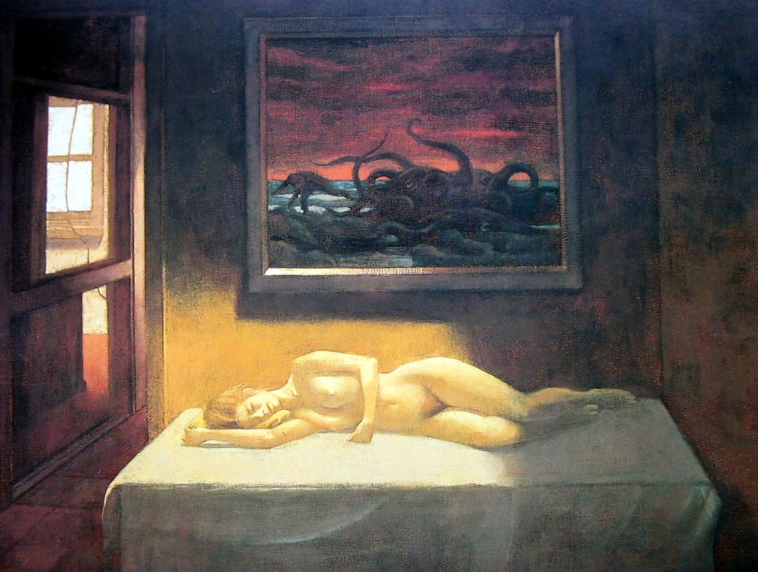

IMAGE A
Amor, Rick. (1993). Sleeping woman [oil on linen, 18 x 130 cm]
Image courtesy the artist and Niagara Galleries, Melbourne
ILLUSTRATION BOOKLET

For copyright reasons this image cannot be reproduced in the online version
of this document.
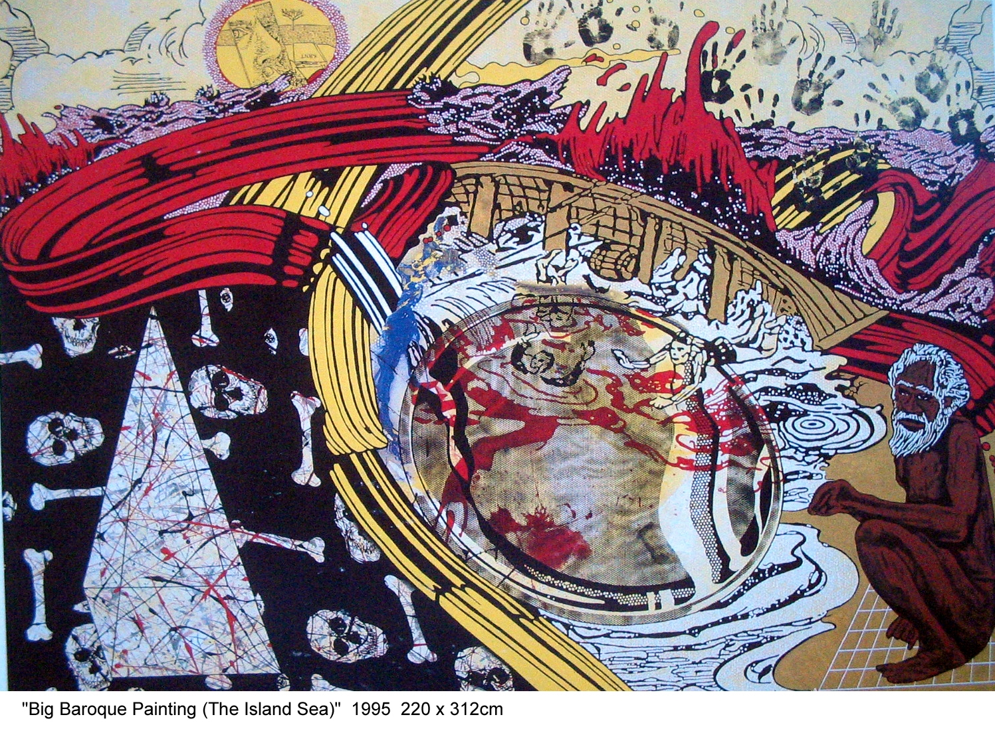

IMAGE B
Bennett, Gordon. (1995). Big baroque painting (The island sea).

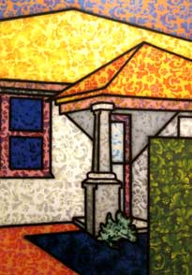

IMAGE C
Arkley, Howard. (1994). Floriated residence.

ILLUSTRATION BOOKLET

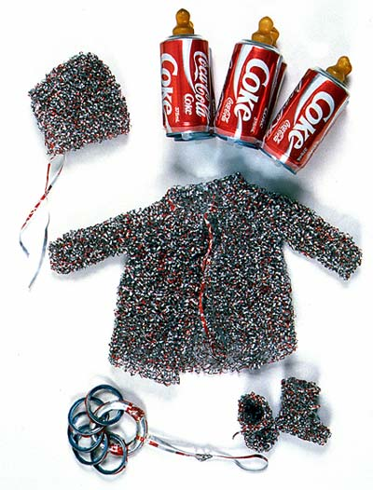
IMAGE D
Hall, Fiona. (1993–94). Medicine bundles for the non-born child [aluminium, rubber teats, child’s jacket (28 x 44 x 10 cm), child’s booties each (8.5 x 9 x 5.2 cm), child’s bonnet (13 x 13 x 7 cm), child’s teething ring (31 x 9 cm diameter)].
Courtesy of the artist and Roslyn Oxley9 Gallery.

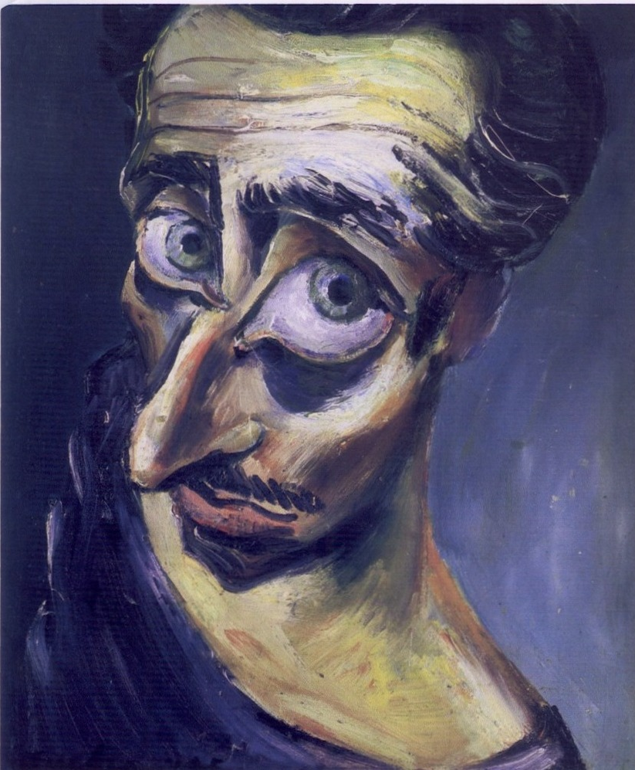

IMAGE E
Tucker, Albert. (1945). Self portrait [oil on board, 41.7 x 32.9 cm].
Heide Museum of Modern Art, Melbourne. On loan from Barbara Tucker 2000.
ILLUSTRATION BOOKLET

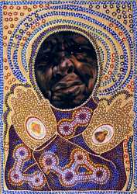

IMAGE F
Dowling, Julie. (1999). Icon to a stolen child: Stigmata.
© Julie Dowling. Licensed by VISCOPY, Australia, 2006.

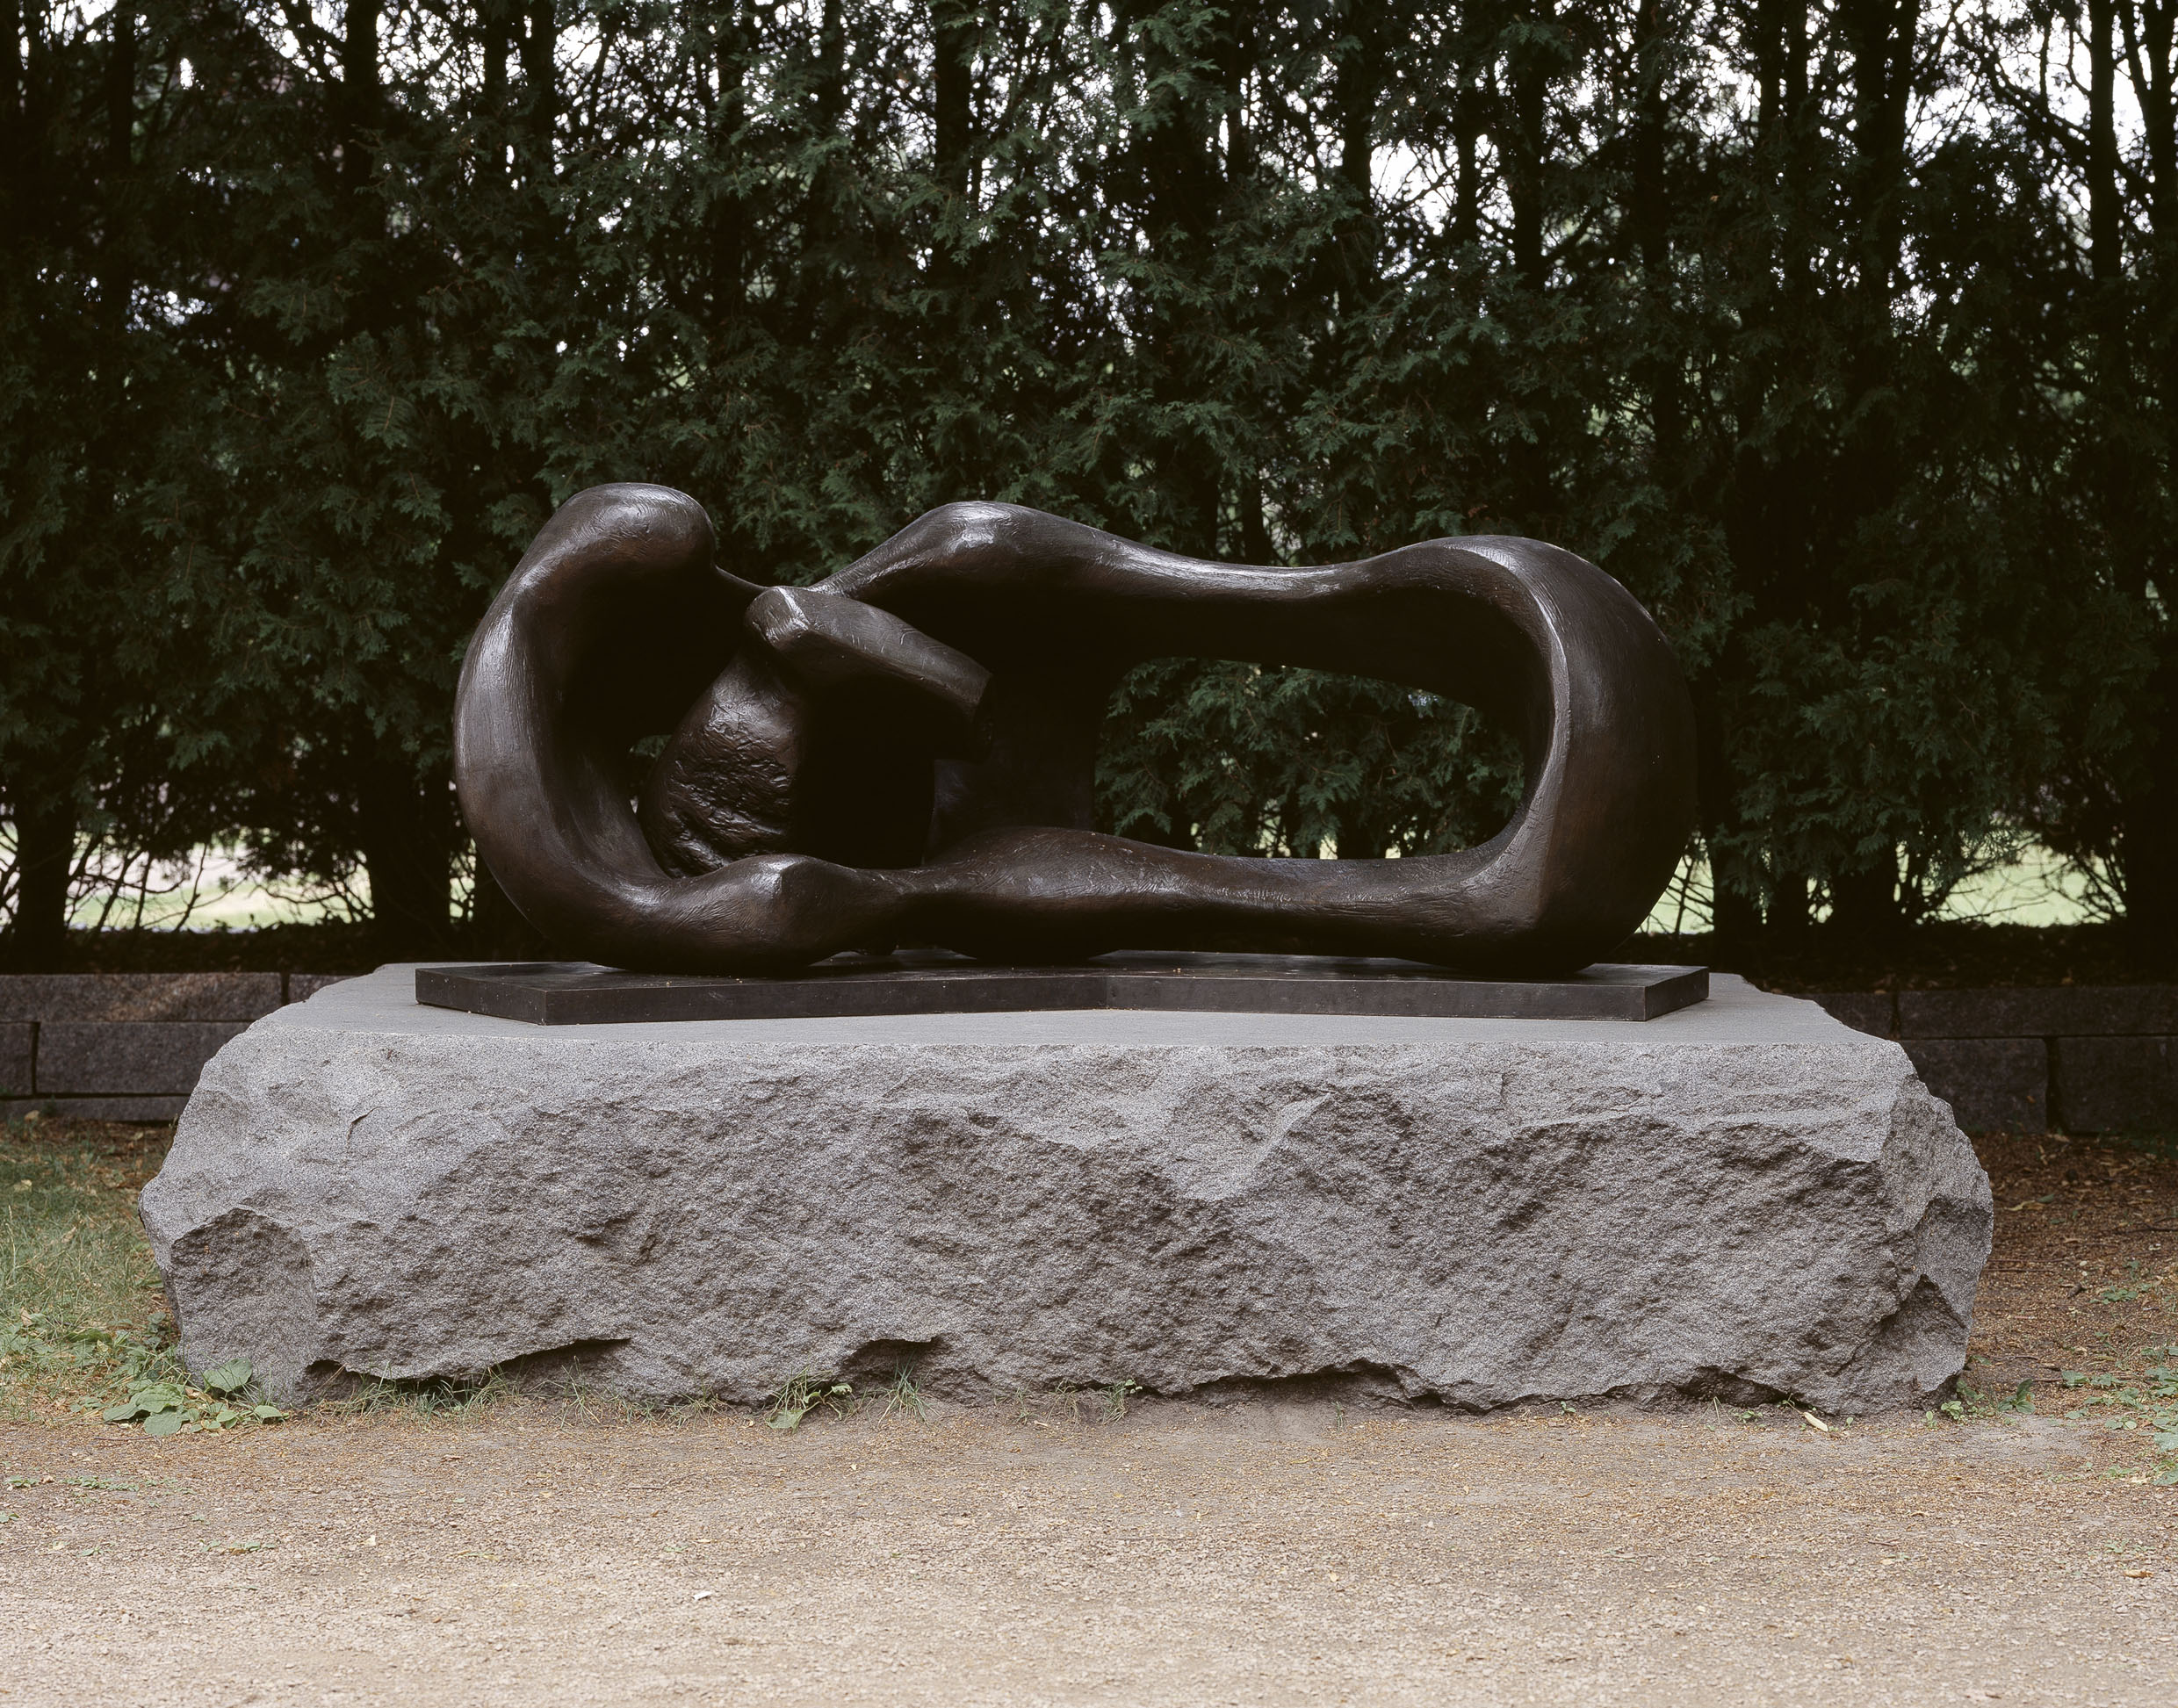

IMAGE G
Moore, Henry. (1960–61). Reclining mother and child [bronze, 90 x 35 x 52in]
Collection Walker Art Center, Minneapolis. Gift of the T.B. Walker Foundation, 1963

© The Henry Moore Foundation www.henry-moore-fdn.co.uk
This image must not be reproduced or altered without prior consent from the Henry Moore Foundation.

